**Burp**

**Gustav:**

| static string Belching(int arrrs)  {  string bealch ="Bu";  for (int i = 0; i < arrrs; i++)  {  bealch += "r";  }  bealch += "p.";  return bealch;  }  } |
| --- |

**Viktor:**



static string LongBurp(int dtghsdgsfgsdfgsdfgdsagsdag) => $"{char.ConvertFromUtf32(0x0062).ToUpper()}{char.ConvertFromUtf32(0x0075)}" + string.Join("", Enumerable.Repeat('R', dtghsdgsfgsdfgsdfgdsagsdag > 0 ? Enumerable.Range(0, dtghsdgsfgsdfgsdfgdsagsdag).Last() : 1)).ToLowerInvariant() + "rP".ToLower();

**Andreas:**

string LongBurp(int r = 1) { return $"Bu{new string('r', r)}p"; }

Fredrik

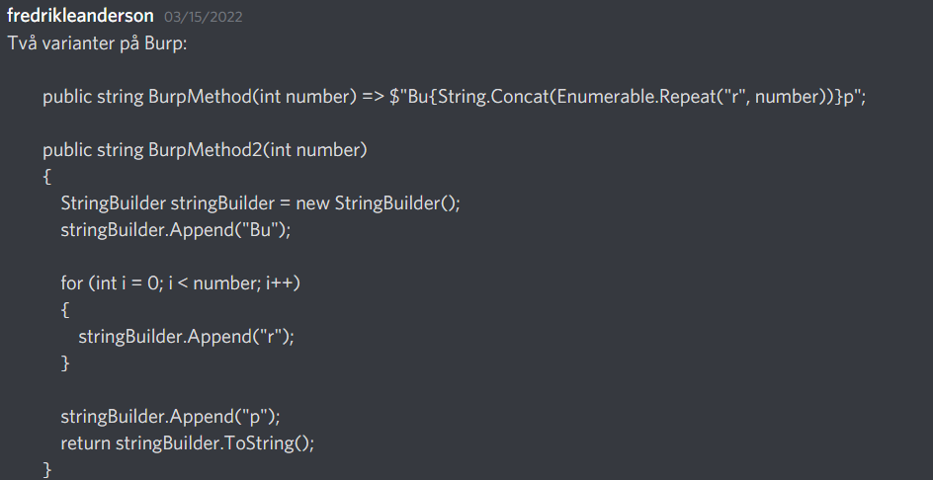

Jing

